

|  |  |  |  |  |  |
| --- | --- | --- | --- | --- | --- |
| Programme | : | **B.Tech.** | Semester | : | **Fall 22-23** |
| Course | : | **CSE3002:**  **Internet and Web Programming Lab** | Slot | : | **L9+L10** |
| Faculty | : | **Dr. M. Premalatha** | Marks | : | **10** |

**Date: 23-08-2022**

**Advait Deochakke**

**20BCE1143**

**Exercise –5**

HTML – **Javascript**

**Note:**

1. **View your registration number in the title bar and snap a screenshot of output along with the title bar.**
2. **Screenshot is required for every modifications of the web page.**
3. A circus has an entry ticket booth. Visitors come to the booth, and order tickets for adults and children. The booth attendant collects the entry fee, and prints out the tickets. Write a JavaScript program (External) to display the total amount in a given text box on clicking ‘Total’ button.

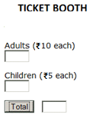

Space

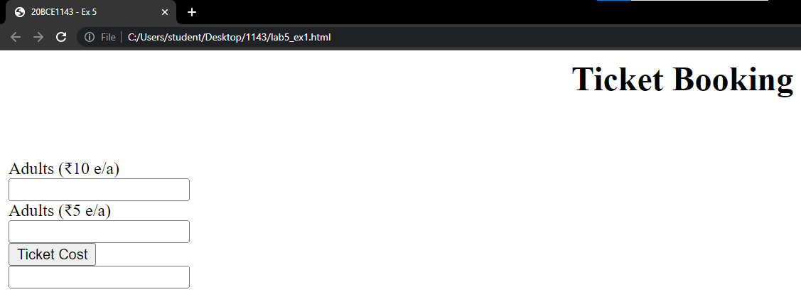

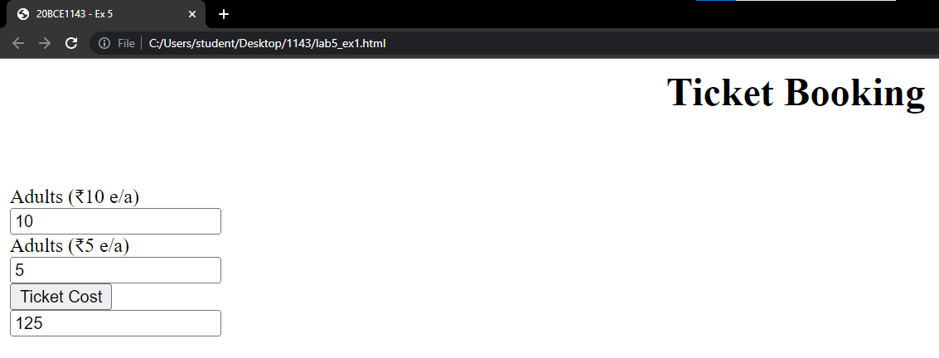

**Code:**

<head>

    <title>20BCE1143 - Ex 5</title>

    <script type="text/javascript" src="my1.js"></script>

</head>

<body>

    <h1 align="center">Ticket Booking</h1>

    <br>

    <br>

    <form>

        <label for="adults">Adults (₹10 e/a)</label><br>

        <input type="text" id="adults" name="adults" value=""><br>

        <label for="kids">Adults (₹5 e/a)</label><br>

        <input type="text" id="kids" name="kids" value=""><br>

        <button type="button" onclick="calc()">Ticket Cost</button><br>

        <input type="text" id="result" name="result" value=""><br>

    </form>

</body>

**JS:**

function calc()

{

    var ad=document.getElementById("adults").value;

    var kds=document.getElementById("kids").value;

    var val=10*ad+5*kds;

    document.getElementById("result").value=val;

}

1. The following are the daily temperature recordings of DELHI (In Fahrenheit) 55,62,68,74,59,45,41,58,60,67,65,78,82,88,91,92,90,93,87,80,78,79,72,68,61,59,55,65 Your JavaScript program should count and print the number of HOT days (High Temperature: 85 or higher), the number of PLEASANT days (High temperature: 60-84) and the number of COLD days (High temperature<60) in the city. It should also display the category of each temperature in an HTML Table. Use JavaScript arrays.

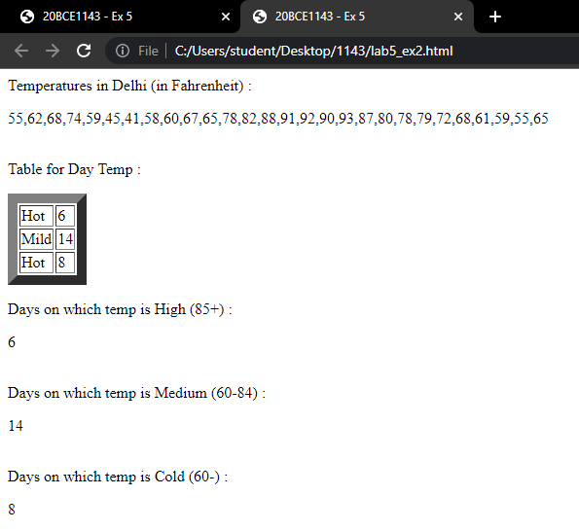

**Code:**

<head>

    <title>20BCE1143 - Ex 5</title>

</head>

<body>

    <script>

        const temp=[55,62,68,74,59,45,41,58,60,67,65,78,82,88,91,92,90,93,87,80,78,79,72,68,61,59,55,65];

    </script>

    Temperatures in Delhi (in Fahrenheit) :

    <br>

    <p id="temp_disp"></p><br>

    <script>

    document.getElementById("temp_disp").innerHTML = temp;

    </script>

    Table for Day Temp :

    <p id="table"></p>

    Days on which temp is High (85+) : <br>

    <p id="hightemp"></p><br>

    Days on which temp is Medium (60-84) : <br>

    <p id="medtemp"></p><br>

    Days on which temp is Cold (60-) : <br>

    <p id="lowtemp"></p><br>

    <script>

        var h=0;

        var m=0;

        var l=0;

        for(let i=0; i<temp.length; i++)

        {

            x=temp[i];

            if(x>=85)

                h=h+1;

            else if(x>60)

                m=m+1;

            else

                l=l+1;

        }

        document.getElementById("table").innerHTML = "<table border=\"10px black solid\"><tr><td>Hot</td><td>"+h+"</td></tr><tr><td>Mild</td><td>"+m+"</td></tr><tr><td>Hot</td><td>"+l+"</td></tr></table>"

        document.getElementById("hightemp").innerHTML = h;

        document.getElementById("medtemp").innerHTML = m;

        document.getElementById("lowtemp").innerHTML = l;

    </script>

</body>

1. Use JavaScript to develop the web page as given in Fig.1 to calculate the Body Mass Index (BMI) and display the adult’s status through appropriate popup boxes. For example, the BMI rate of the men is 21, and then prints the status through a popup box as “Ideal Range” by triggering the event on a “Calculate” button.

Note: Refer Table.1 to get the BMI criteria information.

BMI=703*weight/Height2

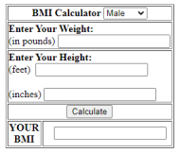

Fig.1. BMI Calculator

Table.1 BMI Criteria

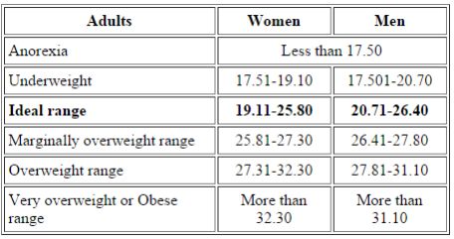

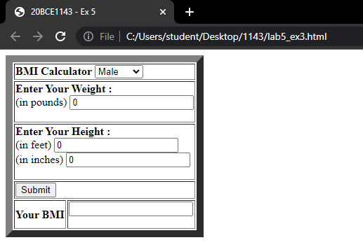

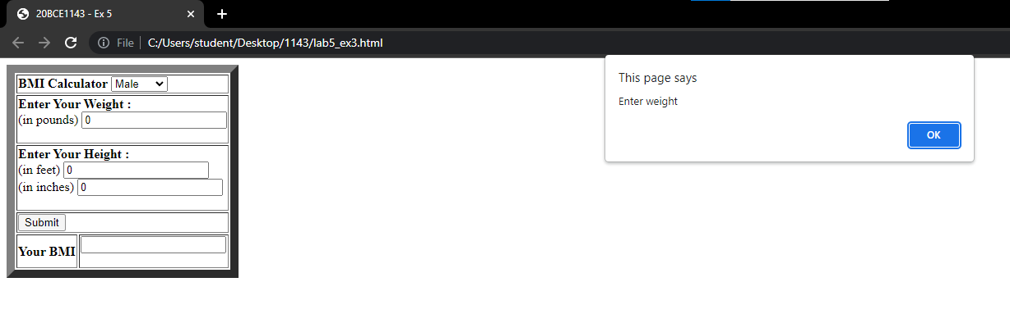

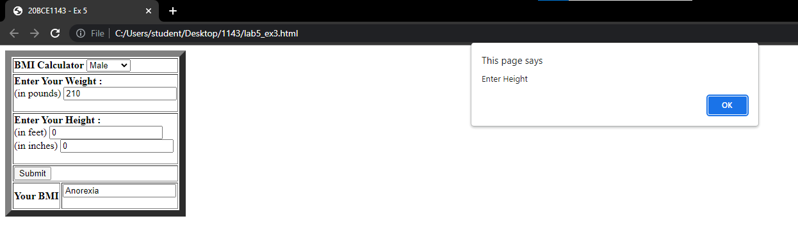

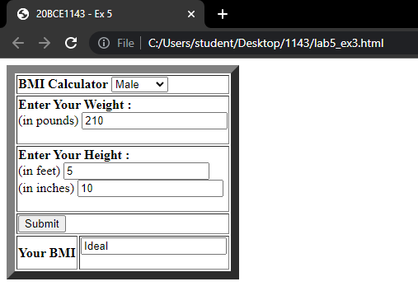

**Code:**

<head>

    <title>20BCE1143 - Ex 5</title>

</head>

<body>

    <script>

        function calc(){

            var pounds=document.getElementById("pnds").value;

            var feet = document.getElementById("feet").value;

            var inch = document.getElementById("inch").value;

            var gender = document.getElementById("gender").value;

            if(pounds <= 0)

                alert("Enter weight");

            if(feet <= 0)

                alert("Enter Height");

            //document.getElementById("demo").innerHTML=gender;

            var bmi_res = 703*pounds/((feet*12+inch)^2);

            //document.getElementById("demo").innerHTML=bmi;

            var bmi="";

            if(bmi_res<17.50)

                bmi=bmi+"Anorexia";

            else if(gender=="F")

            {

                if(bmi_res<19.10)

                    bmi=bmi+"Underweight";

                else if(bmi_res<25.80)

                    bmi=bmi+"Ideal";

                else if(bmi_res<27.30)

                    bmi=bmi+"Marginally Overweight";

                else if(bmi_res<32.30)

                    bmi=bmi+"Overweight";

                else

                    bmi=bmi+"Obese";

            }

            else

            {

                if(bmi_res<20.70)

                    bmi=bmi+"Underweight";

                else if(bmi_res<26.40)

                    bmi=bmi+"Ideal";

                else if(bmi_res<27.80)

                    bmi=bmi+"Marginally Overweight";

                else if(bmi_res<31.10)

                    bmi=bmi+"Overweight";

                else

                    bmi=bmi+"Obese";

            }

                document.getElementById("bmi_res").value=bmi;

        }

    </script>

    <p id="demo"></p>

    <table border="10px black solid">

    <tr><td colspan="2">

        <b>BMI Calculator</b>

    <select name="gender" id="gender">

        <option value="M">Male</option>

        <option value="F">Female</option>

    </select>

    </td></tr>

    <tr><td colspan="2">

        <b>Enter Your Weight : </b><br>

        <form>

            <label for="pnds">(in pounds)</label>

            <input type="text" name="pnds" id="pnds" value="0"><br>

        </form>

    </td></tr>

    <tr><td colspan="2">

        <b>Enter Your Height : </b><br>

        <form>

            <label for="feet">(in feet)</label>

            <input type="text" name="feet" id="feet" value="0"><br>

            <label for="inch">(in inches)</label>

            <input type="text" name="inch" id="inch" value="0"><br>

        </form>

    </td></tr>

    <tr><td colspan="2">

        <button type="button" onclick="calc()">Submit</button>

    </td></tr>

    <tr><td>

        <b>Your BMI</b>

    </td>

    <td>

        <form>

            <input type="text" name="bmi_res" id="bmi_res" value="">

        </form>

    </td></tr>

    </table>

</body>

1. A small airline has just purchased a computer for its newly automated reservations system. Write a JavaScript program to assign seats on each flight (capacity: 10 seats). Your program should display the following:

* If the person types 1, assign a seat in the first-class section (seats 1–5).
* If the person types 2, assign a seat in the economy section (seats 6–10).
* When the first-class section is full, your program should ask the person if it is acceptable to be placed in the economy section (and vice versa)

Allot the seats based on the above choices. Print a boarding pass indicating the person’s name, seat number and class

Use a one-dimensional array to represent the seating chart of the plane. Initialize all the elements of the array to 0 to indicate that all the seats are empty. As each seat is assigned, set the corresponding elements of the array to 1 to indicate that the seat is booked.

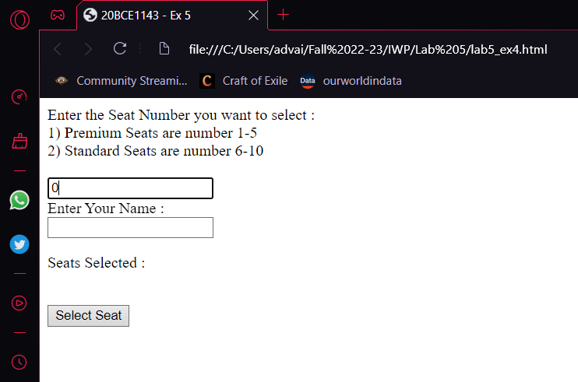

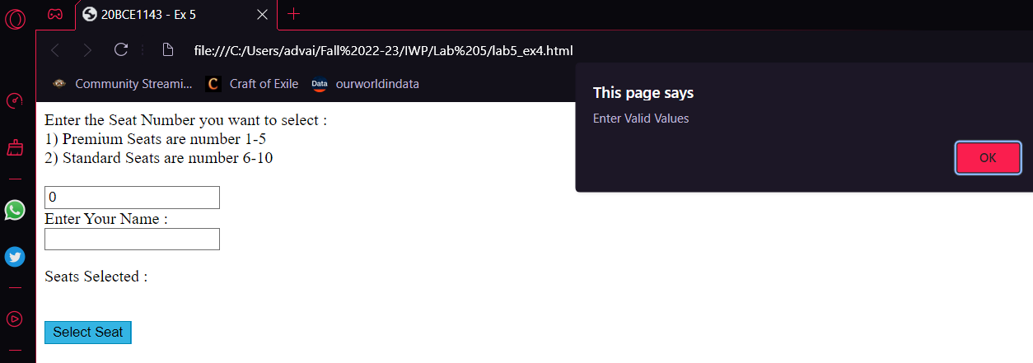

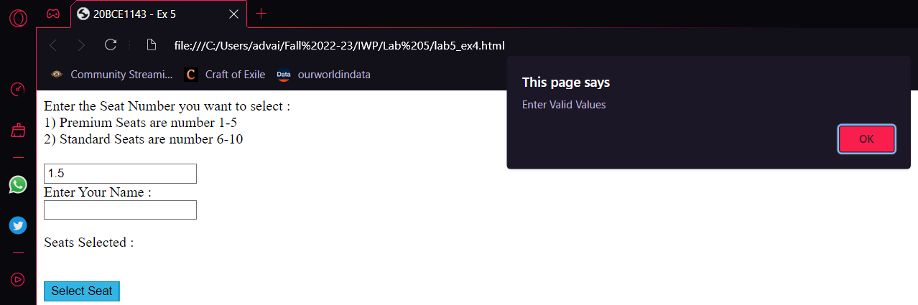

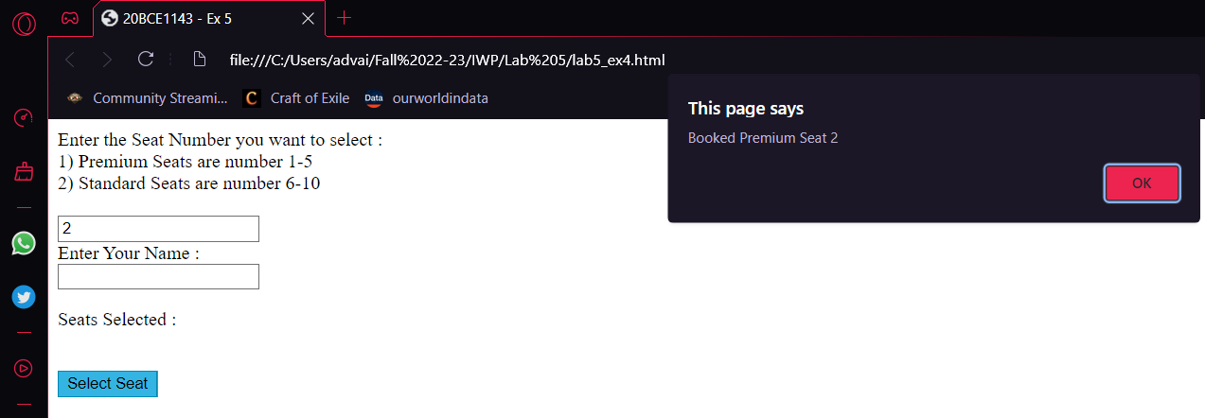

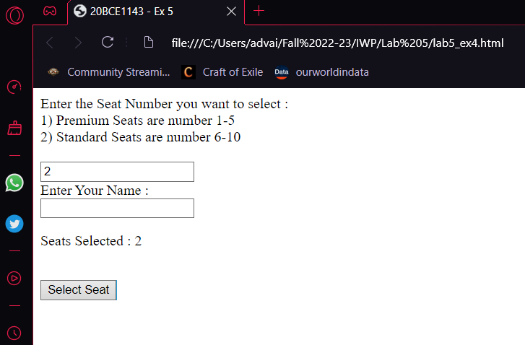

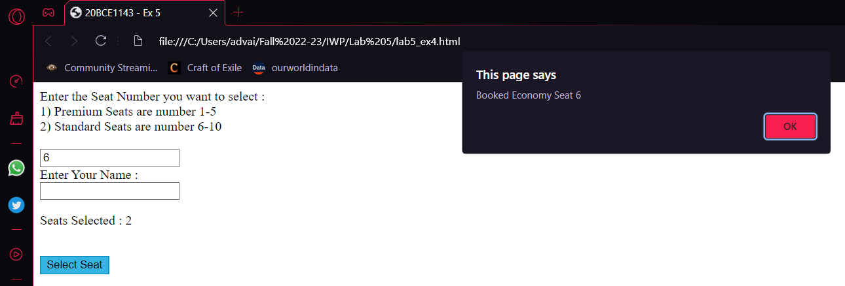

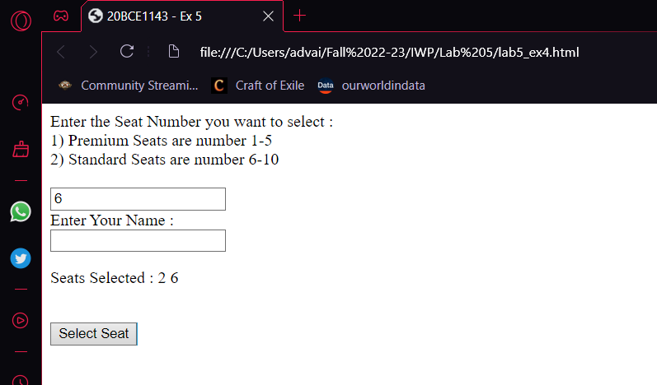

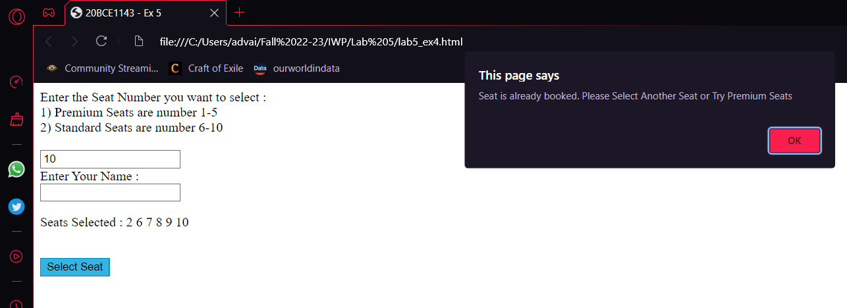

**Code:**

<head>

    <title>20BCE1143 - Ex 5</title>

</head>

<body>

    <script>

        const seats=[0, 0, 0, 0, 0, 0, 0, 0, 0, 0];

    </script>

    <form>

        <label for="seats">

            Enter the Seat Number you want to select : <br>

            1) Premium Seats are number 1-5<br>

            2) Standard Seats are number 6-10<br>

        </label><br>

        <input type="text" name="seats" id="seats" value="0"><br>

        <label for="name">Enter Your Name :</label><br>

        <input type="text" name="Name" id="name" value=""><br>

    </form>

    <p id="seat_disp">

        Seats Selected :

    </p><br>

    <button type="button" onclick="calc()">Select Seat</button>

    <script>

        function calc(){

            var sel_seat=document.getElementById("seats").value;

            if(sel_seat<=0 || sel_seat>10 || sel_seat%1!=0)

                alert("Enter Valid Values");

            else if(!seats[sel_seat] && sel_seat>5)

            {

                seats[sel_seat]=1;

                alert("Booked Economy Seat "+sel_seat);

                document.getElementById("seat_disp").append(" "+sel_seat);

            }

            else if(seats[sel_seat] && sel_seat>5)

            {

                alert("Seat is already booked. Please Select Another Seat or Try Premium Seats");

            }

            else if(!seats[sel_seat])

            {

                seats[sel_seat]=1;

                alert("Booked Premium Seat "+sel_seat);

                document.getElementById("seat_disp").append(" "+sel_seat);

            }

            else if(seats[sel_seat])

            {

                alert("Seat is already booked. Please Select Another Seat or Try Economy Seats");

            }

            document.getElementById("seat_disp").append(" "+document.getElementById("name").value);

        }

    </script>

</body>